3. Navigation System

FEATURES
- A ‘05 DVD navigation system* is available.
- The all-in-one navigation system features an AM/FM/CD/DVD and MP3/WMA (Windows Media Audio) playback support, and Bluetooth hands-free telephone support.
- The number of display colors for maps has been increased to 32,000 for enhanced image quality.
- Basic features of the navigation system such as the search function, route guidance function, and location function have been enhanced for easier operation.
- The help (hint) function has been enhanced, providing information about the destination and menus on the main screen, resulting in easier operation.
- The responsiveness of the navigation controls has been enhanced for greater ease of use.

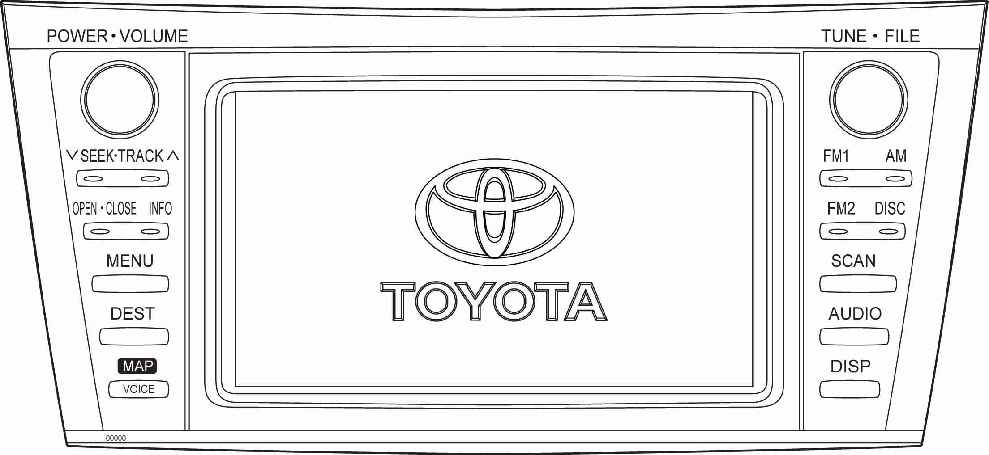
[U1AD]
V1CC-UC-014

*Please refer to the Order Guide for detailed specifications.

V. UTILITY & COMFORT

4. Cruise Control System

V-4. Cruise Control System

1. Cruise Control

FEATURES

- When the driver wants to travel at a constant speed on the highway, the cruise control system* can automatically regulate driving speed without the accelerator being depressed through manipulation of cruise control switches located on the steering wheel.
- In the previous cruise control system, if the vehicle speed dropped below the minimum speed limit of 40 km/h, the cruise control set speed would be erased. In the new system, when the main switch is on, the cruise control set speed will be retained even if the vehicle speed drops below the minimum speed limit.
- When the vehicle speed has returned to at least the cruise control minimum speed limit, pressing the RES (resume) switch will bring the vehicle back to the cruise control set speed.

*Please refer to the Order Guide for detailed specifications.

