Prestressing is a construction methodology which is widely used for bridges and buildings today. The main purpose of prestressing is to induce desirable strains and stresses in structure and its components.
BBR is a leader in this field and we have a full range of prestressing and post-tensioning systems for all structural engineering applications.

BBR has developed a complete range of prestressing systems, ground anchors and stay cable anchorages, covering all applications for structural engineering. These systems are being used by BBR as specialist subcontractor by subsidiary and affiliate companies as well as by licensees.
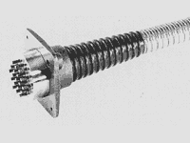  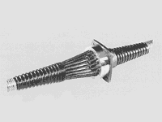 | Standard Tendons consisting of up to 61 strands dia. 0.5" or 42 strands dia. 0.6", have a maximum ultimate capacity of over 11 '000 kN. Usually the strands are installed in the structure by pushing them individually into preplaced ducts of metal or plastic.  Stressable Anchorages consist of an anchor head with different types of bearing plate and trumpet assemblies. All strands are stressed simultaneously and anchored individually by wedges which, by means of the stressing unit, are hydraulically seated in the anchor head for equal gripping.  Fixed Anchorages are either similar to the stressable anchorage or alternatively of the loop-type, whereby each strand is provided with a short loop outside the duct. The loops can be easily formed on the construction site by means of a special light tool.  Coupling Anchorages connect tendons to already stressed ones, anchored at a construction joint. The common anchor head accommodates an equal number of strands from both sides and for safe gripping, wedges and

